**Experiment No. 2.2**

**Student Name: Rishav Kumar UID: 22MCC20039**

**Branch: MCA Section/Group: MCD-1/ Grp B**

**Semester: I Date of Performance: 14th Nov 22**

**Subject Name: ADBMS LAB Subject Code: 22CAP-647**

1. **Aim/Overview of the practical:**

You are given two tables: Students and Grades. Students contains three columns ID, Name and Marks.

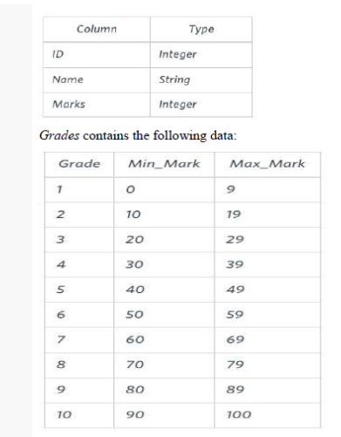

Ketty gives Eve a task to generate a report containing three columns: Name, Grade and Mark. Ketty doesn't want the NAMES of those students who received a grade lower than 8. The report must be in descending order by grade -- i.e. higher grades are entered first. If there is more than one student with the same grade (8-10) assigned to them, order those particular students by their name alphabetically. Finally, if the grade is lower than 8, use "NULL" as their name and list them by their grades in descending order. If there is more than one student with the same grade (1-7) assigned to them, order those particular students by their marks in ascending order.

Write a query to help Eve.

**Sample Input**

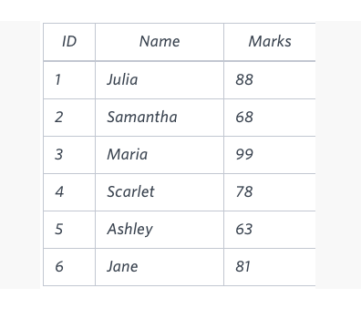

**Sample Output**

Maria 10 99

Jane 9 81

Julia 9 88

Scarlet 8 78

**NULL** 7 63

**NULL** 7 68

**Note**

Print “NULL” as the name if the grade is less than 8.

1. **Code for experiment/practical:**

create table Students(ID int, Name varchar(20), Marks int);  
insert into Students values(1, **"Rishav"**, 98);  
insert into Students values(2, **"Lucky"**, 89);  
insert into Students values(3, **"Tushar"**, 72);  
insert into Students values(4, **"Jesu"**, 65);  
insert into Students values(5, **"Atharav"**, 58);  
insert into Students values(6, **"Shika"**, 92);  
insert into Students values(7, **"Neeti"**, 85);  
  
create table Grades(Grade int, Min_Marks int, Max_Marks int);  
insert into Grades values(1, 0, 9);  
insert into Grades values(2, 10, 19);  
insert into Grades values(3, 20, 29);  
insert into Grades values(4, 30, 39);  
insert into Grades values(5, 40, 49);  
insert into Grades values(6, 50, 59);  
insert into Grades values(7, 60, 69);  
insert into Grades values(8, 70, 79);  
insert into Grades values(9, 80, 89);  
insert into Grades values(10, 90, 100);  
  
  
select case   
when grades.grade >=8 then students.name  
when grades.grade <8 then **"NULL"**end **as** name, grades.grade, students.marks   
**from** students left join grades on Students.marks >= min_marks **and**students.marks <= max_marks  
order by grades.grade desc, students.name asc, students.marks asc;

1. **Tables:**

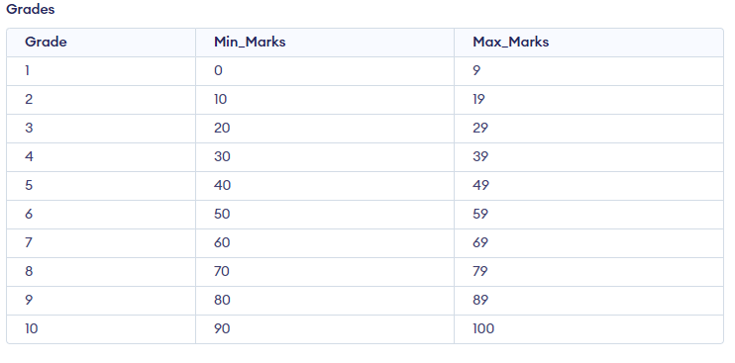

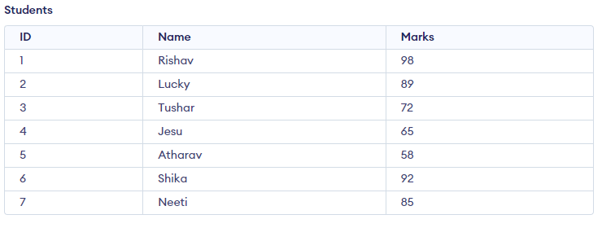

1. **Output:**

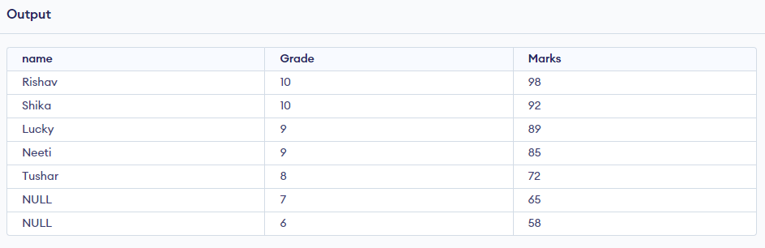

**************************************** **THE END** ***********************************************